List of Licensees
Department of Education (DepEd)
Address : 2nd Floor Department of Education Building, DepEd Meralco Avenue, Pasig, 1605 Metro Manila

The Department of Education (DepEd) formulates, implements, and coordinates policies, plans, programs and projects in the areas of formal and non-formal basic education. It supervises all elementary and secondary education institutions, including alternative learning systems, both public and private; and provides for the establishment and maintenance of a complete, adequate, and integrated system of basic education relevant to the goals of national development.

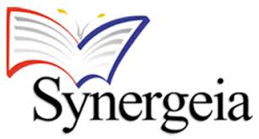
Synergeia Foundation
Address: Unit E and F 131 Sikatuna Uptown Estate
V. Luna Avenue Extension
Sikatuna Village, Quezon City
Synergeia is a coalition of individuals, institutions, and organizations working to improve the quality of basic education.

Filipinas Heritage Library
Address: 6F Ayala Museum
Makati Avenue cor. De la Rosa St.
Makati City, Philippines
The Filipinas Heritage Library boasts of a collection focusing on Philippine history, culture, and arts. In the virtual tour of the library, online exhibits on the Philippine experience during World War II may be viewed.
Provincial Government of Bulacan
Address:

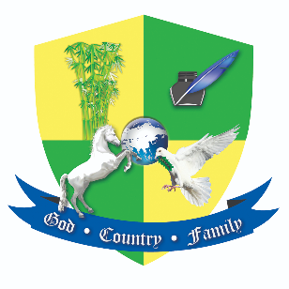

The Manila Times College
Address:

